Assignment: Internet Explorer
Description: Draw and explain the client-server architecture and trace what happens when you open a website.
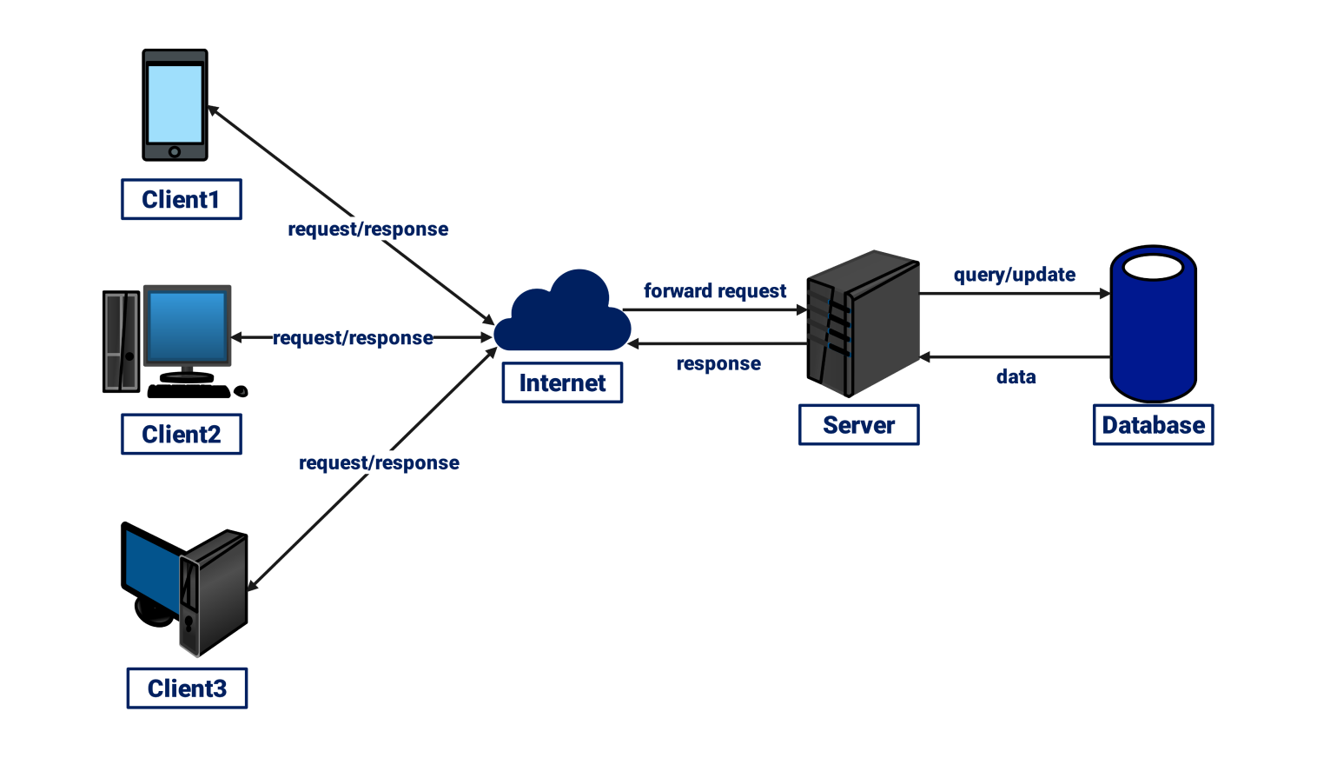
1. Client–Server Architecture
Explanation
Client-Server Architecture is a model where:
- Client → Requests services (Browser like Chrome, Edge)
- Server → Provides services (Web server like Apache, Node.js)
Components:
- Client (Frontend)
  - User interacts through the browser
  - Sends HTTP request to server
- Server (Backend)
  - Processes request
  - Accesses the database if needed
  - Sends response back
- Database
  - Stores data (users, products, etc.)
Flow:
- Client sends request → (e.g., open google.com)
- Server receives request
- Server processes logic
- Server sends response (HTML, CSS, JS)
- Client displays webpage
2. What Happens When You Open a website
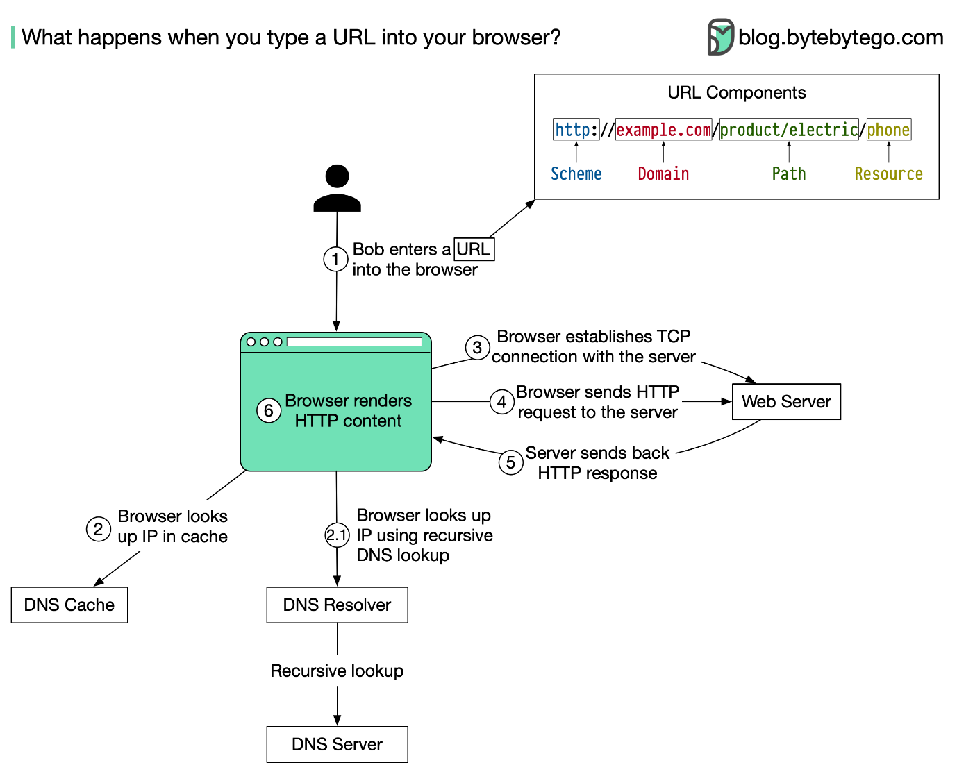

Step-by-Step Explanation
Step 1: Enter URL
- You type www.example.com in browser
Step 2: DNS Lookup
- Browser contacts DNS server
- Converts domain → IP address
(e.g., 142.250.xxx.xxx)
Step 3: TCP Connection
- Browser establishes connection with server
- Uses TCP/IP protocol
Step 4: HTTP Request
- Browser sends request like:
- GET / HTTP/1.1
- Host: example.com
Step 5: Server Processing
- Server:
  - Receives request
  - Runs backend logic
  - Fetches data from database
Step 6: HTTP Response
- Server sends response:
  - HTML (structure)
  - CSS (style)
  - JavaScript (behavior)
Step 7: Browser Rendering
- Browser:
  - Parses HTML → DOM
  - Applies CSS
  - Executes JS
- Finally displays webpage

